Name : Prajakta Keer
Class : TE 10
Roll No : 33231

Problem Statement:- Validate URL, Email, Required using functions empty, preg_match,
filter_var in PHP.
Validating blank inputs:
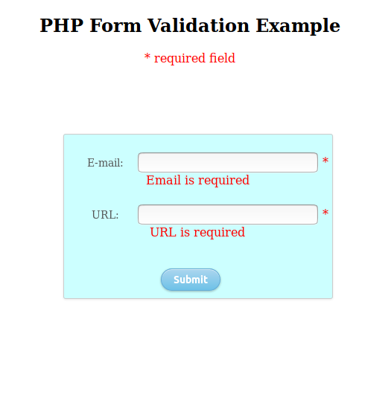

Valid URL, Invalid Email :
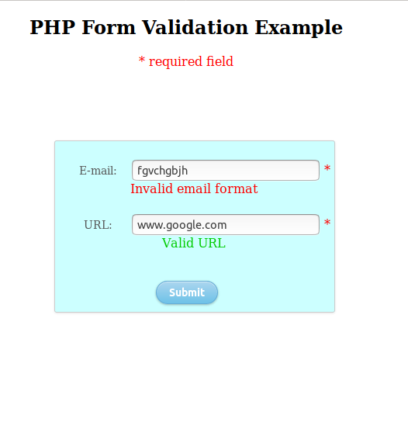

Invalid URL, Valid Email :

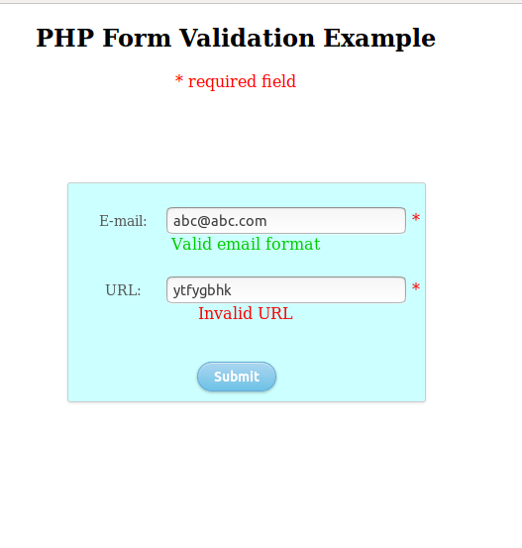

Invalid URL, Invalid Email:

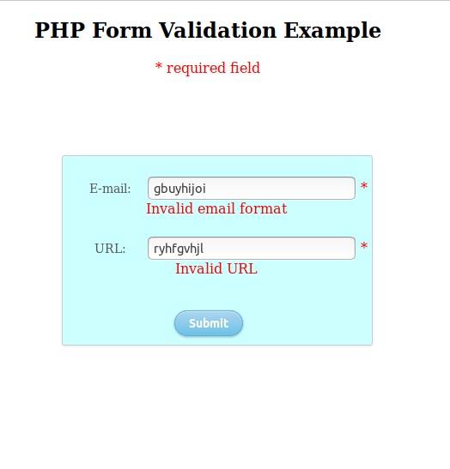

Valid URL, Valid Email:

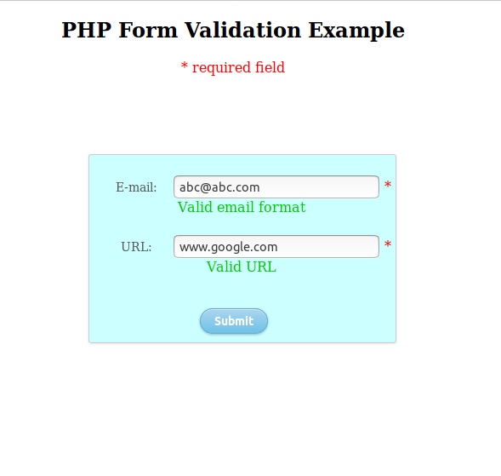

Code:

<!DOCTYPE HTML>
<html>
<head>
<style>
.error {color: #FF0000;}
.correct {color: #00CC00;}
#container {
position: fixed;
width: 360px;
height: 220px;
top: 50%;
left: 50%;
margin-top: -140px;
margin-left: -170px;
background: #CCFFFF;
border-radius: 3px;
border: 1px solid #ccc;
box-shadow: 0 1px 2px rgba(0, 0, 0, .1);
}
form {
margin: 0 auto;
margin-top: 20px;
/*text-align: center;*/
}

label {
color: #555;
display: inline-block;
margin-left: 8px;
padding-top: 10px;
font-size: 14px;
width : 85px;
}

input[type=submit] {
float: center;
margin-right: 20px;
margin-top: 20px;
width: 80px;
height: 30px;
font-size: 14px;
font-weight: bold;
color: #fff;
background-color: #acd6ef; /*IE fallback*/
background-image: -webkit-gradient(linear, left top, left bottom, from(#acd6ef), to(#6ec2e8));
background-image: -moz-linear-gradient(top left 90deg, #acd6ef 0%, #6ec2e8 100%);
background-image: linear-gradient(top left 90deg, #acd6ef 0%, #6ec2e8 100%);
border-radius: 30px;
border: 1px solid #66add6;
box-shadow: 0 1px 2px rgba(0, 0, 0, .3), inset 0 1px 0 rgba(255, 255, 255, .5);
cursor: pointer;
}
</style>
</head>
<body>

<?php
// define variables and set to empty values
$emailErr = $websiteErr = "";
$email = $website = "";

if ($_SERVER["REQUEST_METHOD"] == "POST") {
if (empty($_POST["email"])) {
$emailErr = "Email is required";
} else {
$email = test_input($_POST["email"]);
// check if e-mail address is well-formed
if (!filter_var($email, FILTER_VALIDATE_EMAIL)) {
$emailErr = "Invalid email format";
}
if (filter_var($email, FILTER_VALIDATE_EMAIL) && !empty($_POST["email"])) {
$emailcor = "Valid email format";
}
}

if (empty($_POST["website"])) {
$websiteErr = "URL is required";
} else {
$website = test_input($_POST["website"]);
// check if URL address syntax is valid
if (!preg_match("/\b(?:(?:https?|ftp):\/\/|www\.)[-a-z0-9+&@#\/%?=~_|!:,.;]*[-a-z0-9+&@#\/%=~_|]/i",$website)) {
$websiteErr = "Invalid URL";
}
if (preg_match("/\b(?:(?:https?|ftp):\/\/|www\.)[-a-z0-9+&@#\/%?=~_|!:,.;]*[-a-z0-9+&@#\/%=~_|]/i",$website) && !empty($_POST["website"])) {
$websitecor = "Valid URL";
}
}
}

function test_input($data) {
$data = trim($data);
$data = stripslashes($data);
$data = htmlspecialchars($data);
return $data;
}
?>

<center>
<h2>PHP Form Validation Example</h2>
<p><span class="error">* required field</span></p>
<div id = "container">
<form method="post" action="<?php echo htmlspecialchars($_SERVER["PHP_SELF"]);?>">
<label>E-mail: </label><input type="text" name="email">
<span class="error">* <?php echo $emailErr;?></span>
<span class="correct"><?php echo $emailcor;?></span>
<br><br>
<label>URL: </label><input type="text" name="website">
<span class="error">* <?php echo $websiteErr;?></span>
<span class="correct"><?php echo $websitecor;?></span>
<br><br>
<input type="submit" name="submit" value="Submit">
<!-- <input type="reset" name="submit" value="Reset"> -->
</form></center></div>

</body>
</html>

References :
https://www.w3schools.com/php/DEFAULT.asp

